1.
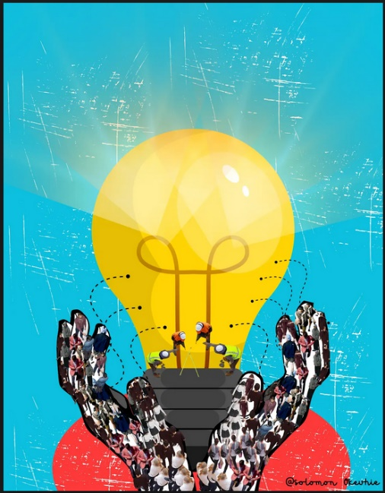
Solomon Okeuhie okeuhie.solomon@gmail.com
https://drive.google.com/file/d/1Qe5ghRThBIUPg2K6uAUoeJ6ntN0wbo5U/view?usp=drivesdk

2

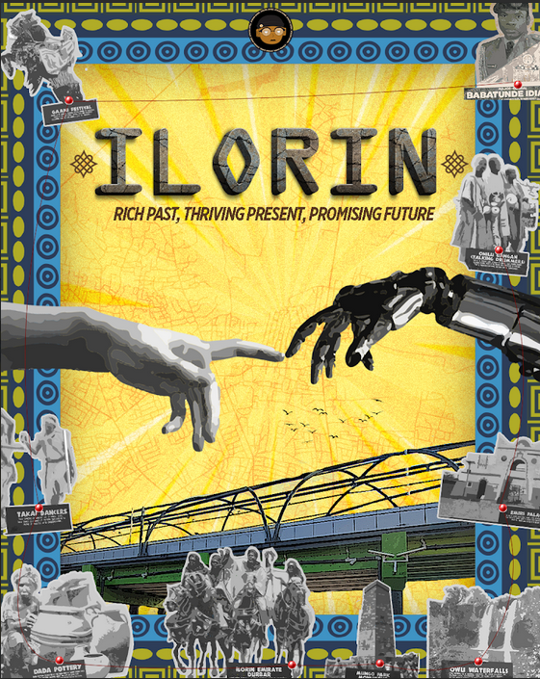
IFEBAJO Stephen Okikioluwa stephenifebajo8@gmail.com
https://drive.google.com/drive/folders/1Imuenvsldpoj_ySEaKEaBlEAstQsAXox?usp=sharing

3.

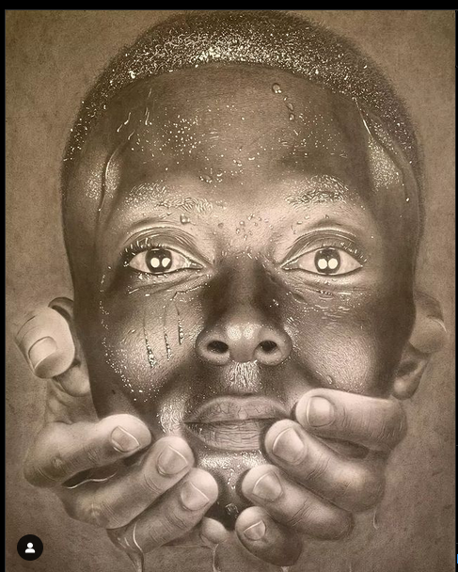
Oluwatobiloba Ogunjobi Artzbyteethegiftedhands@gmail.com
https://www.instagram.com/p/Cj1AAZ_j5ix/?igsh=MWdrcWs3dmd1dmdxag==

4.
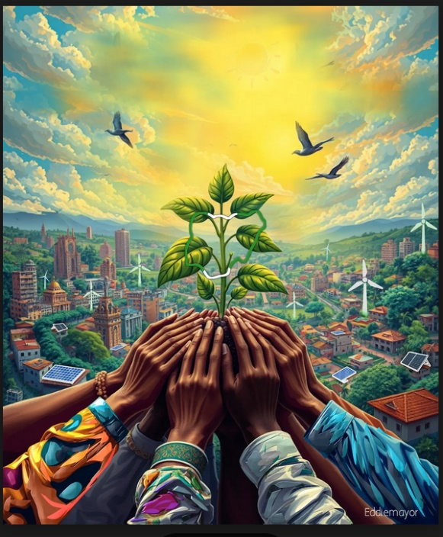
Endurance Oye oyeendurance@gmail.com
https://drive.google.com/file/d/1Gzun2vwe6OoyNCqBGe9SOUbZgFltNv9r/view?usp=drivesdk

5.
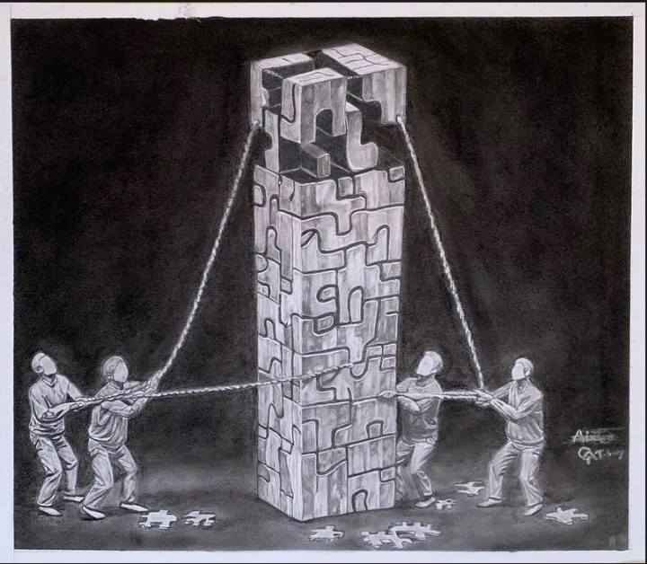
Alani Timilehin alani.timi@gmail.com
https://drive.google.com/file/d/1mtK416xiyVAY91bQOB_NoSXUWXKiXEFK/view?usp=drivesdk

6.

Yusuf abdullateef oluwabukola yusufoluwabukola1@gmail.com
https://drive.google.com/file/d/1lBEfovEsqH6RPMI2FVDJX_JRfy2mWi9A/view?usp=drivesdk

7.
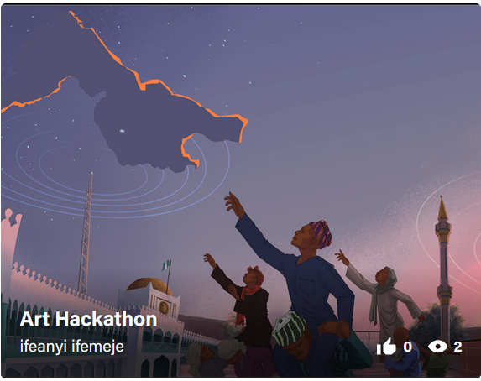
Ifeanyi Ifemeje larvakingsgmail.com
https://www.behance.net/Carlosketch

8
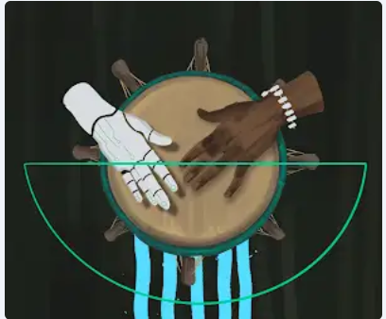
Kabir Isah dansallah.k.i@gmail.com
https://drive.google.com/drive/folders/1--AfJRECpL2RykzREYX8OVCoq5D75w8p

9.
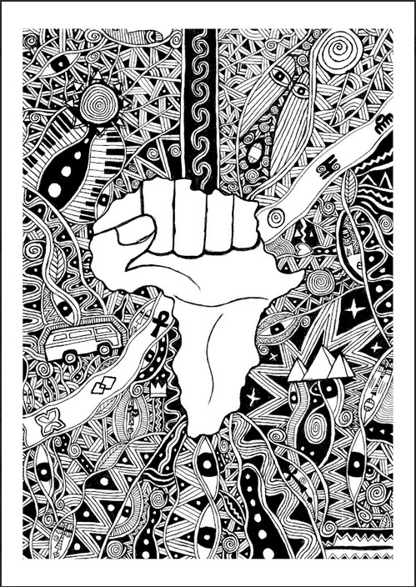
David Oluremi perfectavid@gmail.com
https://drive.google.com/drive/folders/1Xg6p8xeRFs8dkZcv-hhfxue67lmKbnGM?usp=sharing

10.

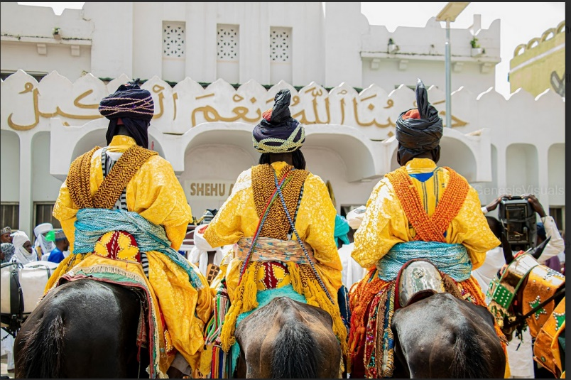

Iyowu Michael iyowumichael97@gmail.con
https://drive.google.com/drive/folders/1nYGqbQQz0epD-VTHXgx8V-o0K4qplwco

